SubHub the App that Makes and Delivers your Own Personalized Sandwich

Project Requirements

- Login Screen – username and password

Will ask the user for username and password to create their profile in first time use and will save it. After you may save password and username for auto login or you may manually enter password every time.

- Home Screen- contains all tabs and most likely has an advertisement

Saves your previously recorded sandwich bought and makes recommendations-based sales and new sandwiches that you might be interested in. If you tap any recommendation and or favorite it will ask you to add to your cart and avoid all hassle.

- Sandwich finder- find specific ingredients at sandwich shops

The Sandwich finder allows you to choose which sandwich shop you want to order from (Subway, Jersey Mikes, etc.). This will pop up any deals that are specific to the shop or the most popular. A specific feature is that it also shows you where only specific ingredients may be at a specific shop. This will also include noncommercial sandwich shops and will have your local ones that are unfamiliar to other people.

- Sandwich builder- ingredients specific to certain sandwiches

The sandwich builder is its own tab that allows you to choose the ingredients of the sandwich specific to that shop. Choice of bread, Meat, Vegetables, sauce, etc. This will also allow you to tell any specific notes on how to make your sandwich so the shop will know.

It will also include a vegetarian or option to take all meat-based products off of the builder.

This will also include premade sandwiches by the specific shop. For instance, a meatball sub, BLT, etc. The premade sandwiches can also be altered after you click on it. If the customer doesn’t want the sandwich completely the same this option is there for the customer

- Cart – put orders into this car

The Cart only allows you to input items into the cart once you build a sandwich. Once the Sandwich is entered you are allowed to add any items that may come with the sandwich at the specific sandwich shop. For instance, cookies, drinks, chips, etc. The Cart will automatically update the price for you and confirm what you order.

- Snacks - adds to drink and sandwich

Every chip and cookie will only be specific to each shop. Will only allow you to choose from shops inventory.

- Drinks - put into cart add to sandwich

Drinks are only specific to the shop you order from.

- Digital Wallet/Gift card/credit redeemer- put credits on to your account

Digital Wallet gives extra credits based on how much you use the app. Sometimes may come with birthday or holiday promotions. These promotions will give you a certain amount of credits you could possibly use at checkout. You can input your card information and or at checkout redeem your credit or gift card to pay for the sandwich.

- Link to door dash for delivery or Pickup

Connects your profile and order to door dash and allows you to pay through them to get your delivery. The door dash delivery service will give you instructions and updates of where your sandwich is and when it is delivered. Or it tells you where your sandwich is waiting. The pickup option allows you to tell specific instructions to the shop on how you want it prepared and left for you to simply walk in and grab it.

- Settings-Profile= email, phone

The settings will allow the user to change their email and or phone number at any time along with their payment info and delivery info. The app will ask for this information as soon as you open it for the first time.

- Security check – authentication

To check your password and or other info you must authenticate your identity with an email sent to the user. The email will contain a link and a code to authenticate your account.

- Favorites to save on home screen

The app gives you the power to favorite orders, so you don’t have to re input every ingredient over again to buy the same sandwich.

- Recommendations saved to home screen

Based on your past orders it will recommend your orders based on it. Recommend different sandwiches and or ingredients based on the favorites and orders you have done in the past. Could also contain specials at sandwich shops.

- Specials

These specials are given by specific shops or by the app itself.

- Sandwich catalog

Allows you to search for sandwiches and reviews. These catalogs show recommendations on a longer list and are linked to the review feature so you may see how others rated a sandwich.

- Review feature of sandwiches

Allows you to write reviews of Sandwich shops and even specific sandwiches you tried and or always order. Allow you to communicate with other people and rate their reviews. Tells other users what sandwich you ordered at each shop.

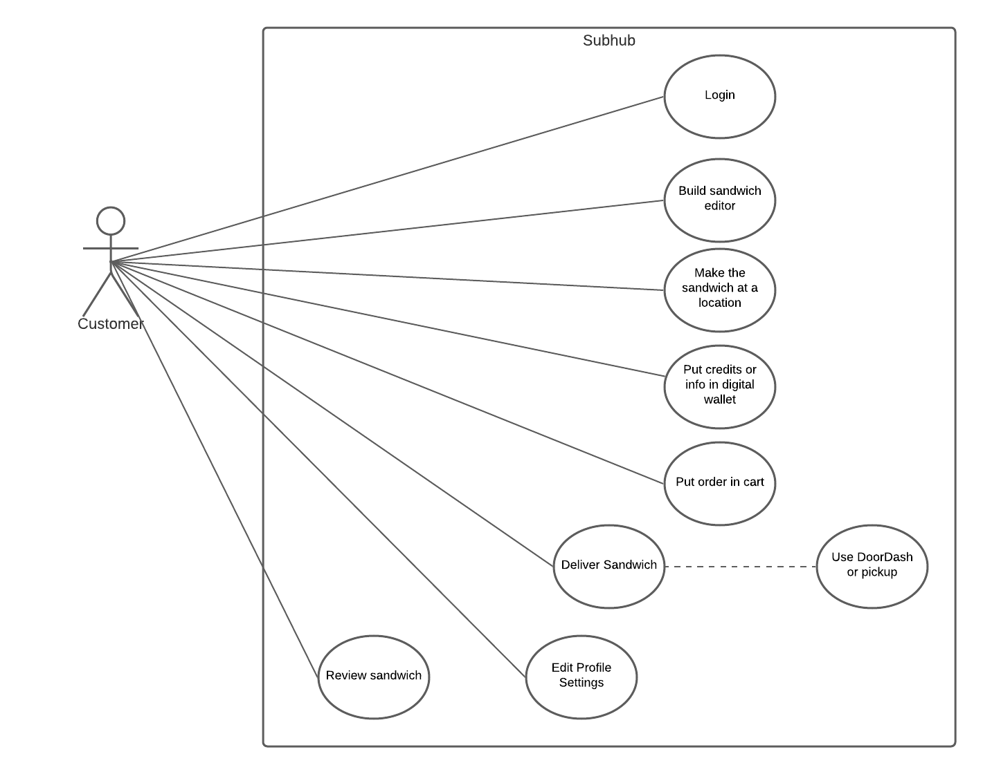

SubHub is an app for sandwich enthusiasts where you make a sandwich with your own specific ingredients, and it matches to a specific place where they make and deliver it to you. You can also review the sandwiches you order and post them to a platform.